Implementation Manual – The Book of Exodus

Main Menu:

The first screen is simply a background image of Moses splitting the Red Sea with his staff.

There are two buttons:

Start button – Takes you to the first screen of the program.

Exit button – Exits the window.

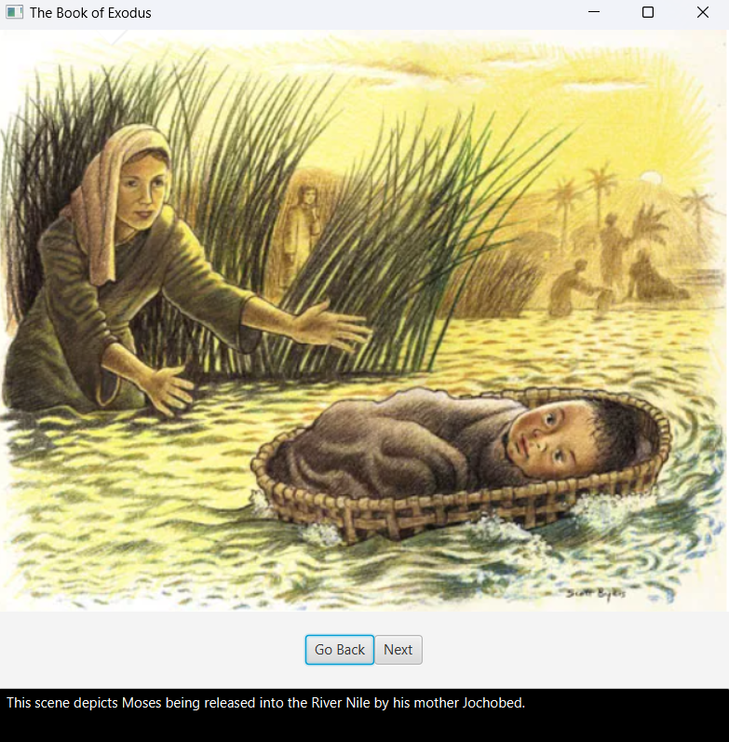

First screen:

The background image is of Moses’ mother releasing him into the River Nile

There are two buttons on this screen:

Go back button – Allows you to go back to the main menu

Next button – Takes you to the next screen

Text box – Provides an explanation of the scene

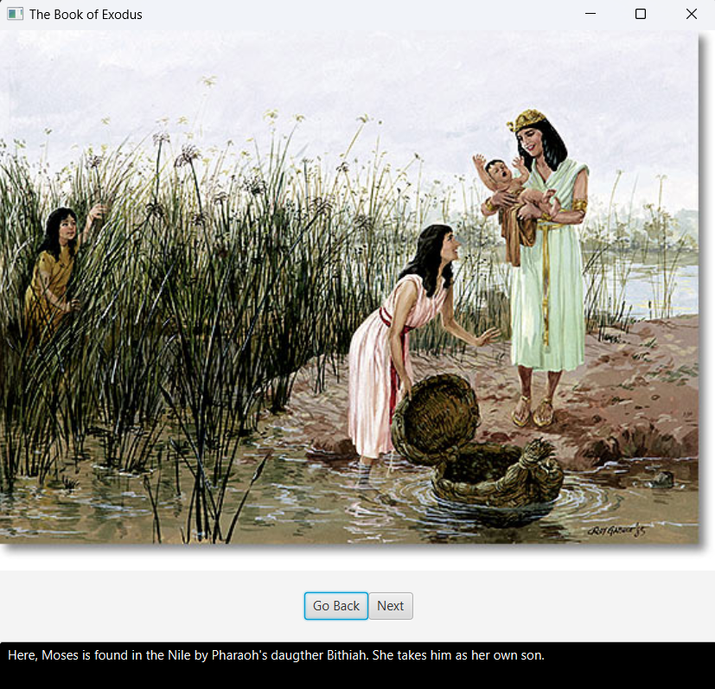

Second Screen:

The background image is of Pharaoh’s daughter finding Moses in the River Nile

There are two buttons on this screen:

Go back button – Allows you to go back to the first

Next button – Takes you to the next screen

Text box – Provides an explanation of the scene

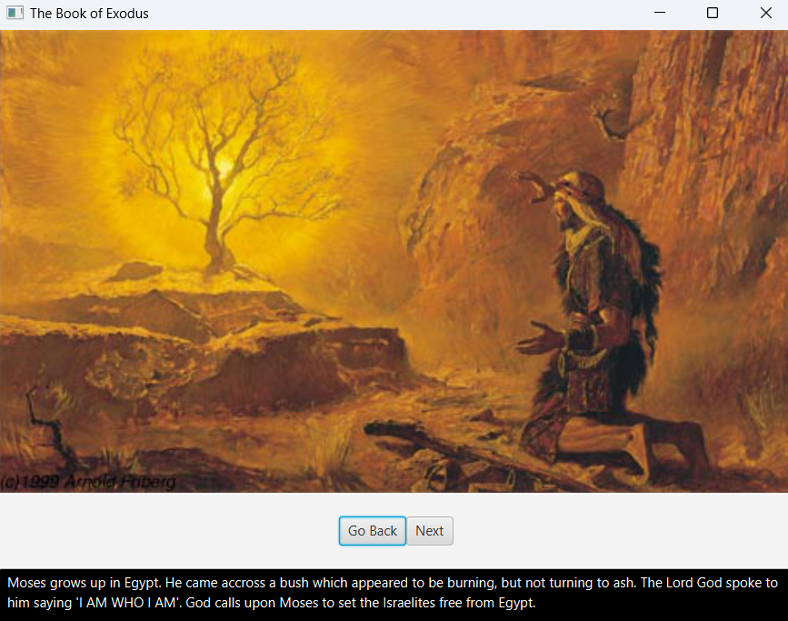  
Third Screen:

The background image is of Moses grown up approaching God in the burning bush

There are two buttons on this screen:

Go back button – Allows you to go back to the second screen

Next button – Takes you to the next screen

Text box – Provides an explanation of the scene

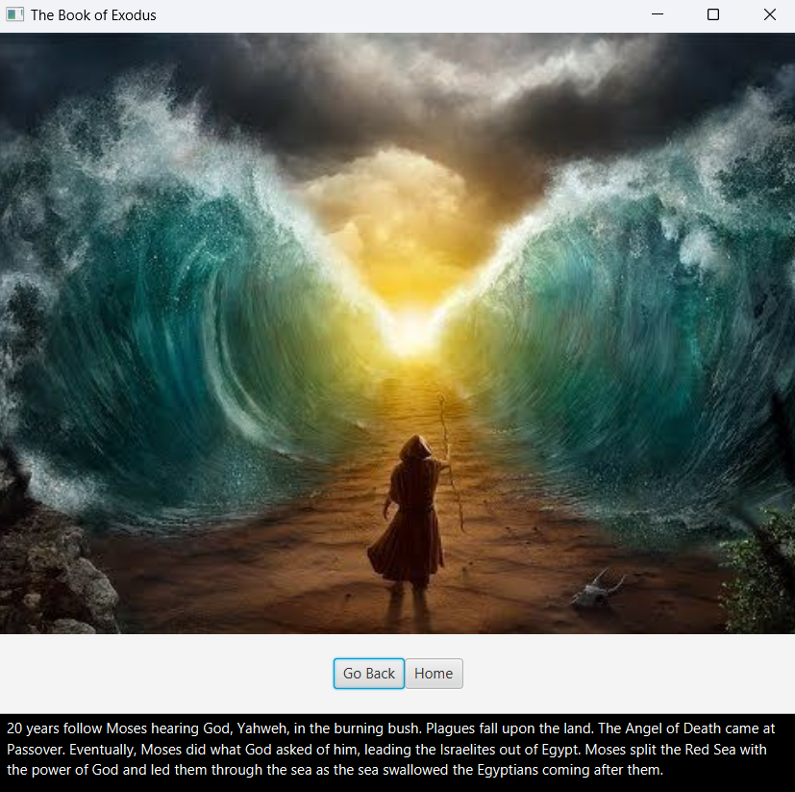

Fifth Screen:

The background image is of Moses splitting the Red Sea with his staff

There are two buttons on this screen:

Go back button – Allows you to go back to the third screen

Home button – Takes you to the main menu screen

Text box – Provides an explanation of the scene